**Adding a network adapter to a virtual machine**

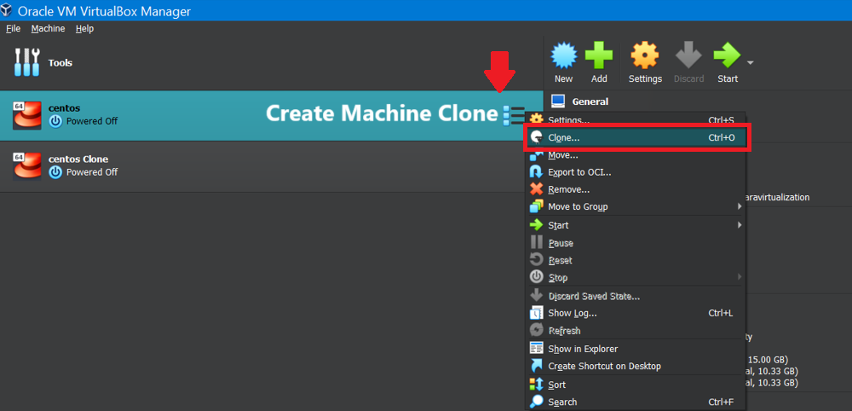

Choose Internal N/W:

Internal Network: It creates a private network between the host and the VMs.

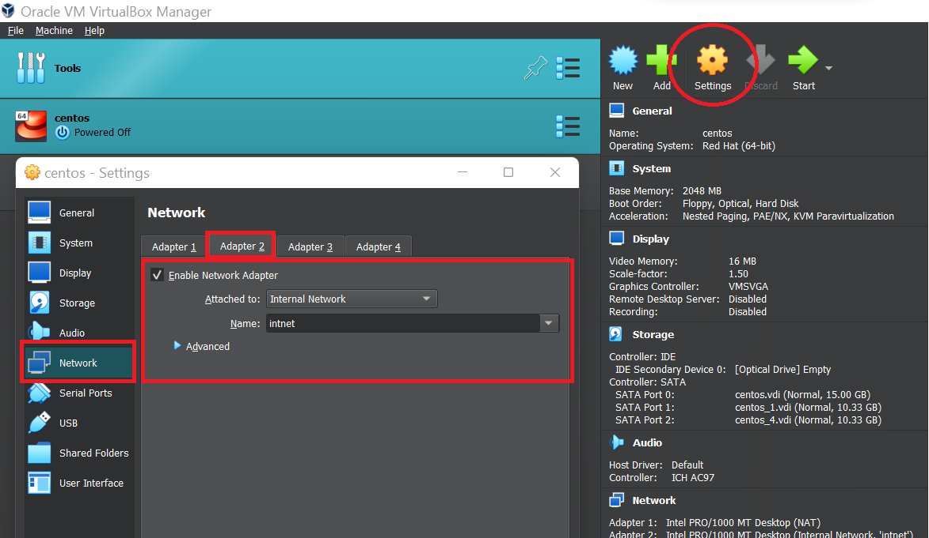

Start the machines

Go to Network Manager Using nmtui command

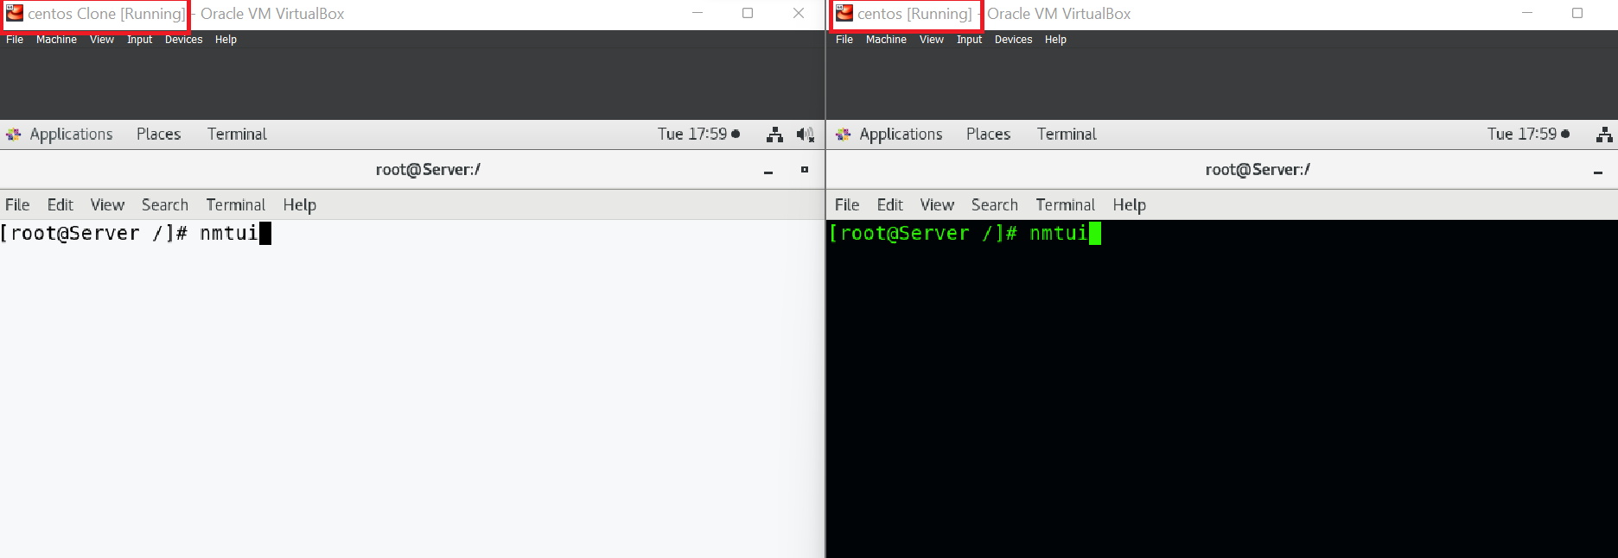

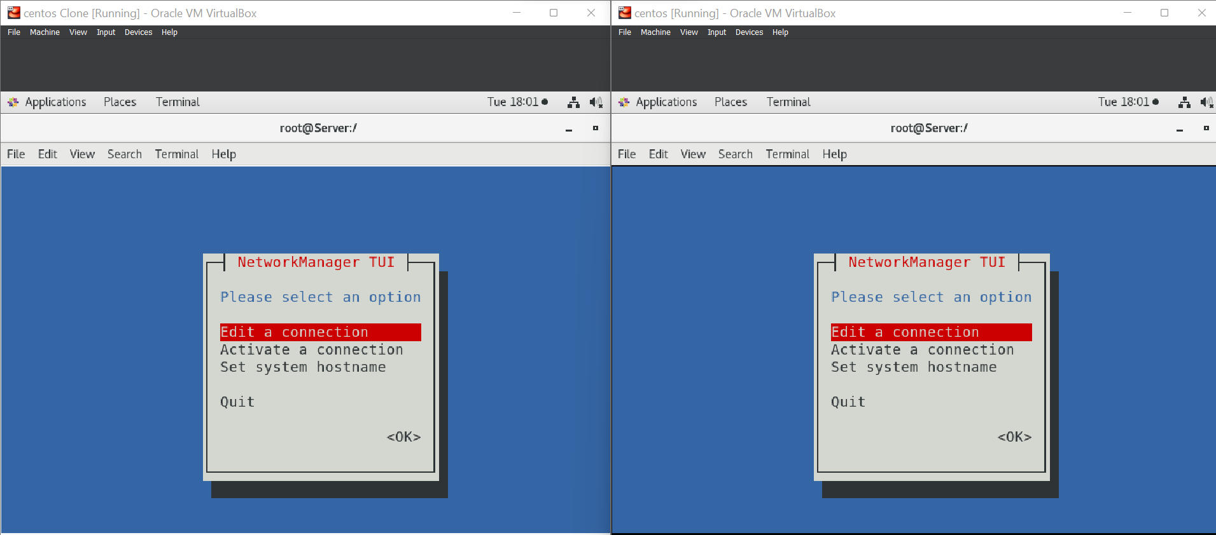

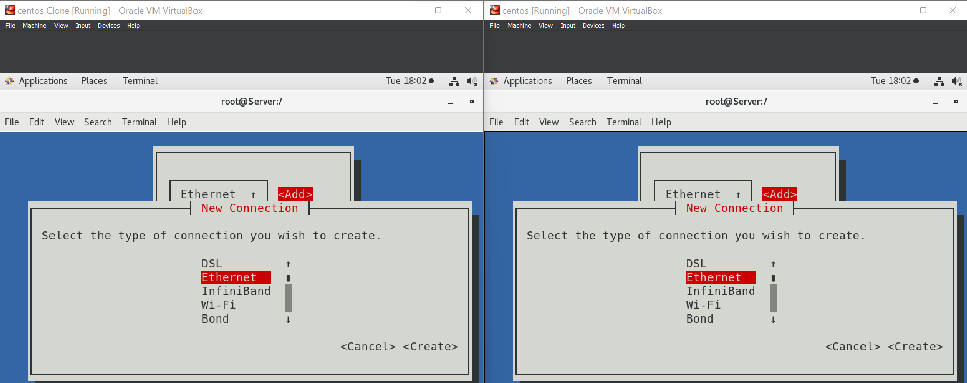

Make Sure ipv4 addresses must be of same range

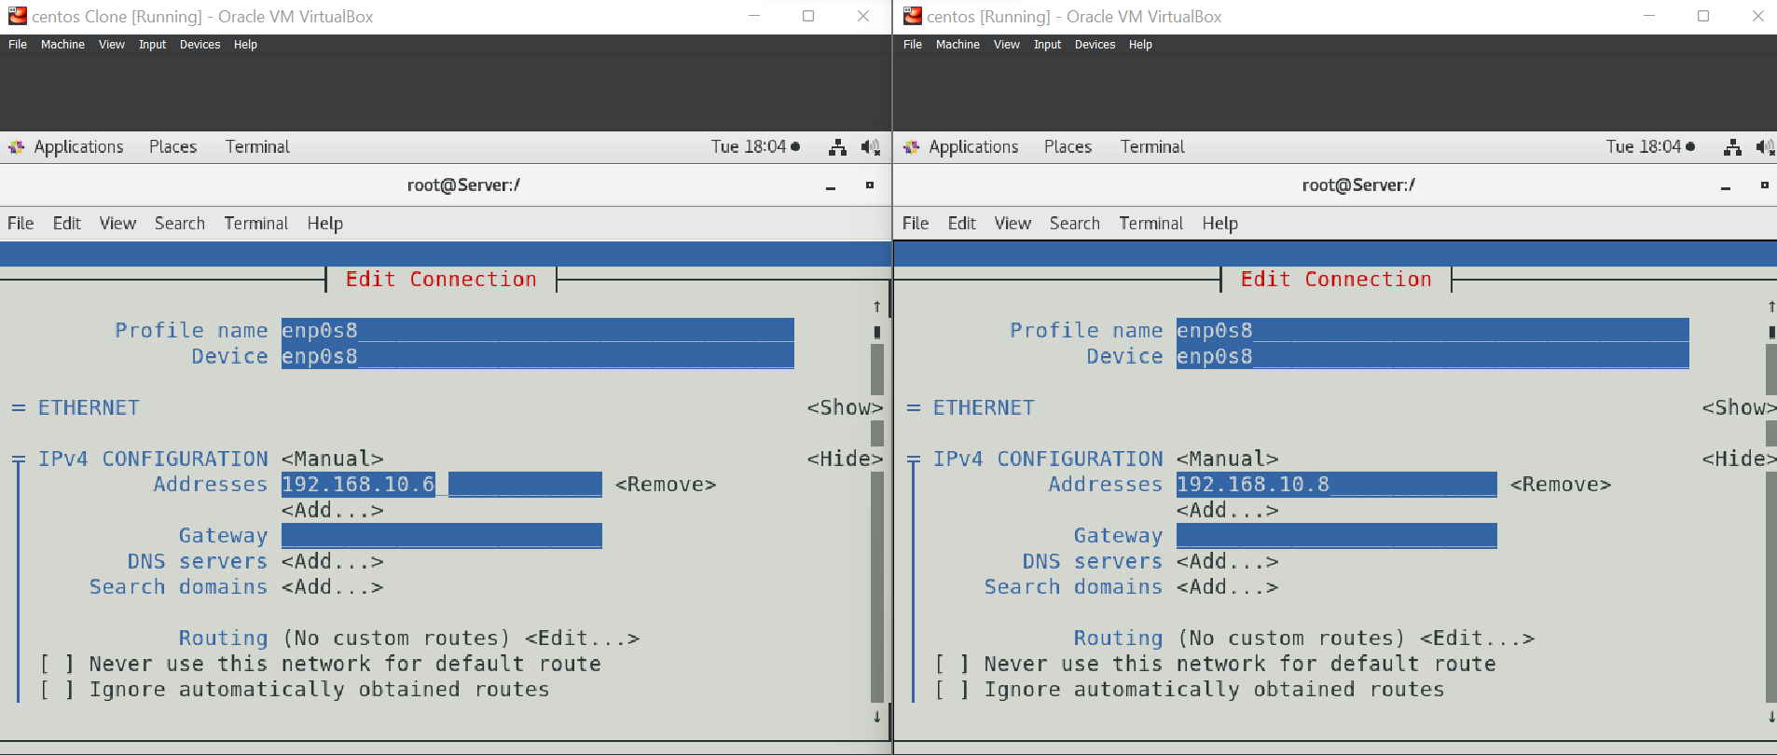

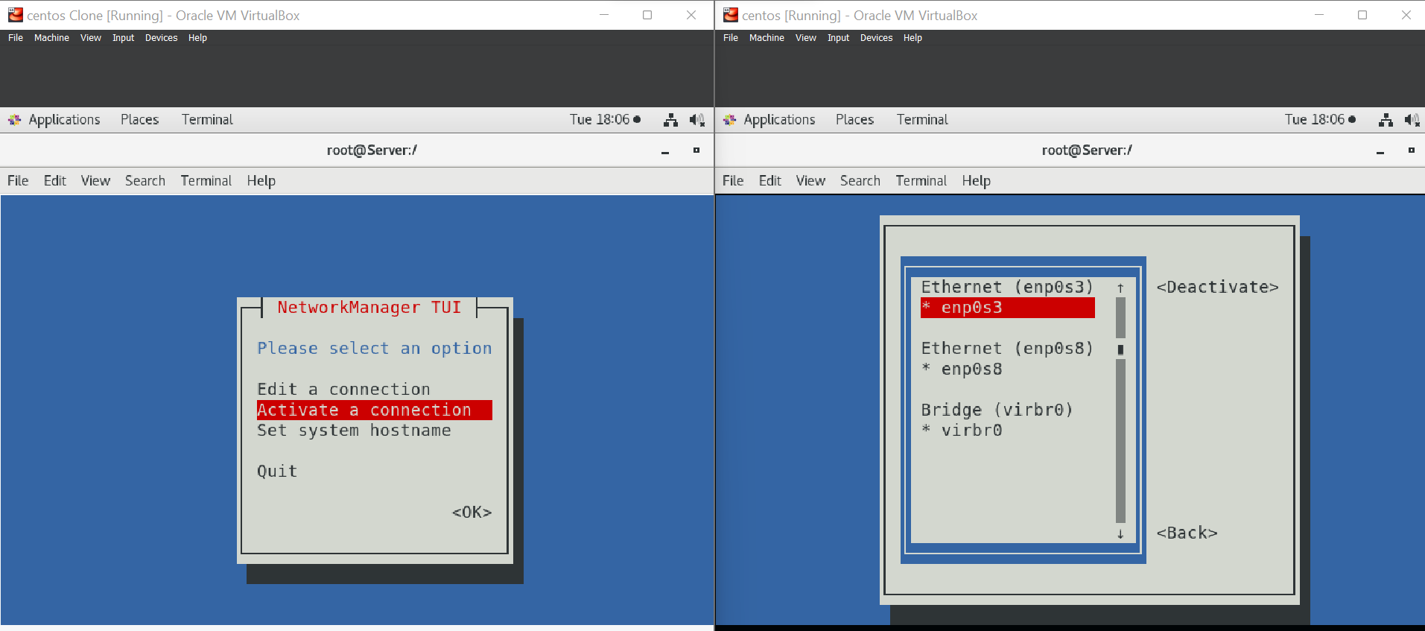

Ping Clone ip into main server and vice versa to test network connectivity

